**Que 1 →** First we clone the repo from assignment link and create our own repo file.

root@DESKTOP-PDOJQQA:k8s-assignment# **git clone git@github.com:vivekmore2001/docker-sample-nginx.git**

Receiving objects: 100% (9/9), done.

Resolving deltas: 100% (2/2), done.

root@DESKTOP-PDOJQQA:k8s-assignment# **ll**

total 0

drwxrwxrwx 1 vivek vivek 512 Feb 21 12:22 **docker-sample-nginx/**

root@DESKTOP-PDOJQQA:k8s-assignment#

root@DESKTOP-PDOJQQA:k8s-assignment# cd docker-sample-nginx/

root@DESKTOP-PDOJQQA:docker-sample-nginx# ll

total 0

drwxrwxrwx 1 vivek vivek 512 Feb 21 12:22 .git/

-rwxrwxrwx 1 vivek vivek 95 Feb 21 12:22 Dockerfile*

-rwxrwxrwx 1 vivek vivek 286 Feb 21 12:22 default.conf*

-rwxrwxrwx 1 vivek vivek 255 Feb 21 12:22 index.html*

root@DESKTOP-PDOJQQA:docker-sample-nginx# **git checkout -b release**

Switched to a new branch 'release'

root@DESKTOP-PDOJQQA:docker-sample-nginx# git checkout master

Switched to branch 'master'

Your branch is up to date with 'origin/master'.

root@DESKTOP-PDOJQQA:docker-sample-nginx# **git checkout -b main**

Switched to a new branch 'main'

root@DESKTOP-PDOJQQA:docker-sample-nginx# git checkout master

Switched to branch 'master'

Your branch is up to date with 'origin/master'.

root@DESKTOP-PDOJQQA:docker-sample-nginx# **git checkout -b hotfix**

Switched to a new branch 'hotfix'

root@DESKTOP-PDOJQQA:docker-sample-nginx# **git checkout master**

Switched to branch 'master'

Your branch is up to date with 'origin/master'.

root@DESKTOP-PDOJQQA:docker-sample-nginx#

root@DESKTOP-PDOJQQA:docker-sample-nginx# ll

total 0

drwxrwxrwx 1 vivek vivek 512 Feb 21 12:22 ./

drwxrwxrwx 1 vivek vivek 512 Feb 21 12:22 ../

drwxrwxrwx 1 vivek vivek 512 Feb 21 12:24 .git/

-rwxrwxrwx 1 vivek vivek 95 Feb 21 12:22 Dockerfile*

-rwxrwxrwx 1 vivek vivek 286 Feb 21 12:22 default.conf*

-rwxrwxrwx 1 vivek vivek 255 Feb 21 12:22 index.html*

root@DESKTOP-PDOJQQA:docker-sample-nginx# vi index.html

root@DESKTOP-PDOJQQA:docker-sample-nginx# **docker image build --no-cache -t vivekmore5292/cloudethix_master_nginx_vivek:v1 .**

[+] Building 41.7s (9/9) FINISHED docker:default

=> [internal] load build definition from Dockerfile 0.1s

=> => transferring dockerfile: 132B 0.0s

=> [internal] load metadata for docker.io/library/nginx:alpine 36.0s

=> [auth] library/nginx:pull token for registry-1.docker.io 0.0s

=> [internal] load .dockerignore 0.1s

=> => transferring context: 2B 0.0s

=> [1/3] FROM docker.io/library/nginx:alpine@sha256:6a2f8b28e45c4adea04ec207a251fd4a2df03ddc930f782af51e315ebc76e9a9 4.3s

=> => resolve docker.io/library/nginx:alpine@sha256:6a2f8b28e45c4adea04ec207a251fd4a2df03ddc930f782af51e315ebc76e9a9 0.0s

=> => extracting sha256:c7059f3102784cd05dc96fff74a52bce9fa50fea724ece08748507fa3455999b 0.0s

=> => extracting sha256:a101c9a82b88a3fa561030af162d98a130ca3bc0501b2e70594410dd426f2c9b 0.0s

=> => extracting sha256:d6a456492aaa4c003389fec3da0939f31c505232fcf1925db314815a196c444f 0.0s

=> exporting to image 0.2s

=> => exporting layers 0.2s

=> => writing image sha256:09702256db892b309fa368419026769f8a6295bd3b7eeaa79beec358a95bd30b 0.0s

=> => naming to docker.io/vivekmore5292/cloudethix_master_nginx_vivek:v1 0.0s

root@DESKTOP-PDOJQQA:docker-sample-nginx# **docker push vivekmore5292/cloudethix_master_nginx_vivek:v1**

The push refers to repository [docker.io/vivekmore5292/cloudethix_master_nginx_vivek]

82f144c747c8: Pushed

834d91bd28e4: Pushed

667a247707f0: Mounted from library/nginx

d8527026595f: Mounted from library/nginx

2593b08e5428: Mounted from library/nginx

9909978d630d: Mounted from library/nginx

c5140fc719dd: Mounted from library/nginx

3137f8f0c641: Mounted from library/nginx

718db50a47c0: Mounted from library/nginx

aedc3bda2944: Mounted from library/nginx

v1: digest: sha256:0fa75572d35aad76d6ce0c4ec5867bfc11ea8fb93d8e56f3e8076f08c310b7fe size: 2403

root@DESKTOP-PDOJQQA:docker-sample-nginx**# git checkout release**

M index.html

Switched to branch 'release'

root@DESKTOP-PDOJQQA:docker-sample-nginx# ll

total 0

-rwxrwxrwx 1 vivek vivek 95 Feb 21 12:22 Dockerfile*

-rwxrwxrwx 1 vivek vivek 286 Feb 21 12:22 default.conf*

-rwxrwxrwx 1 vivek vivek 281 Feb 21 12:25 index.html*

root@DESKTOP-PDOJQQA:docker-sample-nginx# vi index.html

root@DESKTOP-PDOJQQA:docker-sample-nginx# **docker image build --no-cache -t vivekmore5292/cloudethix_release_nginx_vivek:v1 .**

**root@DESKTOP-PDOJQQA:docker-sample-nginx# docker push vivekmore5292/cloudethix_release_nginx_vivek:v1**

**f8ed2ed12378: Pushed**

**dcbef20f66c5: Pushed**

**aedc3bda2944: Mounted from vivekmore5292/cloudethix_master_nginx_vivek**

v1: digest: sha256:c18a7aca9904cb5575492d8b5c01fde63fc99d23fd4e44b523eb7625c00a32c9 size: 2403

**Create two directories** **kube/clusterIP**

-rwxrwxrwx 1 vivek vivek 95 Feb 21 12:22 Dockerfile*

drwxrwxrwx 1 vivek vivek 512 Feb 21 12:55 **clusterIP/**

-rwxrwxrwx 1 vivek vivek 286 Feb 21 12:22 default.conf*

-rwxrwxrwx 1 vivek vivek 282 Feb 21 12:37 index.html*

drwxrwxrwx 1 vivek vivek 512 Feb 21 12:52 **kube/**

**Create two yaml file**

-rwxrwxrwx 1 vivek vivek 464 Feb 21 13:05 master_pod.yaml*

-rwxrwxrwx 1 vivek vivek 473 Feb 21 13:05 release_pod.yaml*

root@DESKTOP-PDOJQQA:kube# **cat master_pod.yaml**

apiVersion: apps/v1

kind: Deployment

metadata:

name: master-nginx

spec:

selector:

matchLabels:

app: master-nginx

template:

metadata:

labels:

app: master-nginx

spec:

containers:

- name: master-nginx

image: vivekmore5292/cloudethix_master_nginx_vivek:v1

resources:

limits:

memory: "128Mi"

cpu: "500m"

ports:

- containerPort: 80

root@DESKTOP-PDOJQQA:kube# **cat release_pod.yaml**

apiVersion: apps/v1

kind: Deployment

metadata:

name: release-nginx

spec:

selector:

matchLabels:

app: release-nginx

template:

metadata:

labels:

app: release-nginx

spec:

containers:

- name: release-nginx

image: vivekmore5292/cloudethix_release_nginx_vivek:v1

resources:

limits:

memory: "128Mi"

cpu: "500m"

ports:

- containerPort: 80

**Create one cluster_ip-service.yaml**

root@DESKTOP-PDOJQQA:clusterIP# cat cluster_ip-service.yaml

apiVersion: v1

kind: Service

metadata:

name: cloudethix-clusterip

spec:

selector:

app: release-nginx

ports:

- port: 80

targetPort: 80

type: ClusterIP

**create and apply pod.**

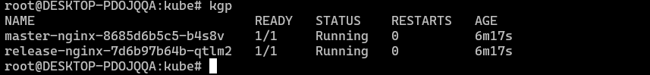

access master_nginx pod shell & curl the master_nginx pod.

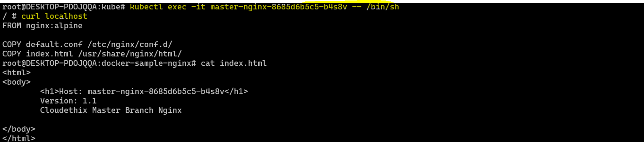

Same for release_nginx pod.

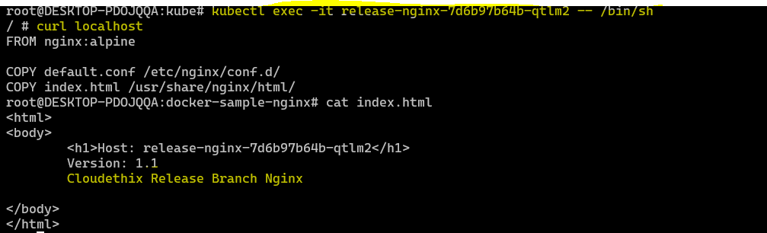

**Que 2 →** [https://kubernetes.io/docs/tasks/access-application-cluster/connec ting-frontend-backend/](https://kubernetes.io/docs/tasks/access-application-cluster/connec%20ting-frontend-backend/)

Create 4 files and copy code from this link.

root@DESKTOP-PDOJQQA:kube-NodePort# ll

total 1

drwxrwxrwx 1 vivek vivek 512 Feb 21 14:43 ../

-rwxrwxrwx 1 vivek vivek 485 Feb 21 15:07 backend-deployment.yaml*

-rwxrwxrwx 1 vivek vivek 177 Feb 21 15:08 backend-service.yaml*

-rwxrwxrwx 1 vivek vivek 220 Feb 21 16:27 frontend-NodePort-service.yaml*

-rwxrwxrwx 1 vivek vivek 535 Feb 21 15:03 frontend-deployment.yaml*

Apply and create pods.

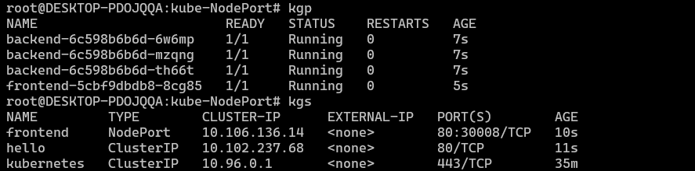

Run web-browser and check the output

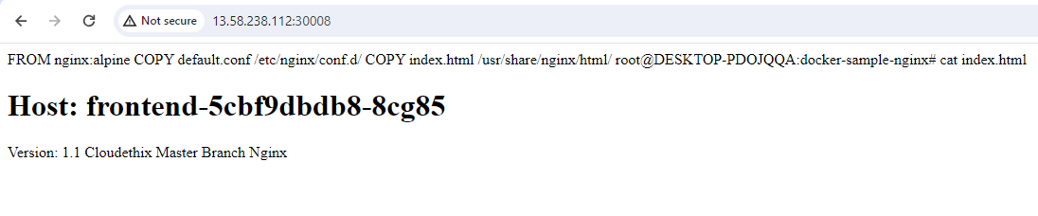

**Que 3 →** Create any 2 pods and assign them to different worker nodes with nodeName property.

Create 2 yaml files for assigning worknodes.

-rwxrwxrwx 1 vivek vivek 204 Feb 21 16:39 worknode1.yaml*

-rwxrwxrwx 1 vivek vivek 204 Feb 21 16:40 worknode2.yaml*

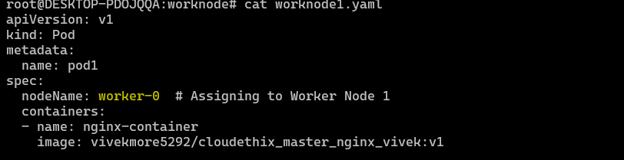

Check the nodes which is assign.

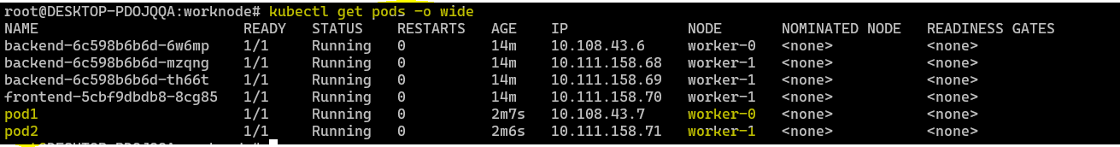

**Que 4 →** Label both worker nodes such as worker-0 node as cloudethix-k8s-00 & worker-1 node as cloudethix-k8s-01.

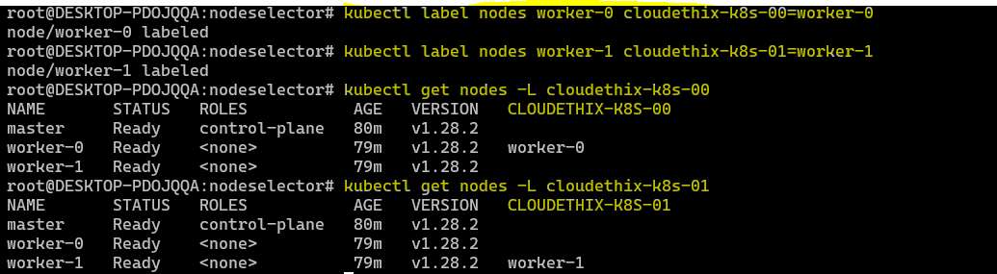

**Que 5 →** Clone the below repo locally & create DaemonSet from directory DaemonSet101. <https://github.com/collabnix/kubelabs>

root@DESKTOP-PDOJQQA:daemon# ll

total 0

drwxrwxrwx 1 vivek vivek 512 Feb 21 18:28 ./

drwxrwxrwx 1 vivek vivek 512 Feb 21 18:24 ../

-rwxrwxrwx 1 vivek vivek 0 Feb 21 18:28 daemon.yaml*

root@DESKTOP-PDOJQQA:daemon# **kgp**

NAME READY STATUS RESTARTS AGE

prometheus-daemonset-l7x8f 1/1 Running 0 7s

prometheus-daemonset-m6js5 1/1 Running 0 7s

root@DESKTOP-PDOJQQA:daemon# **kubectl get daemonsets/prometheus-daemonset**

NAME DESIRED CURRENT READY UP-TO-DATE AVAILABLE NODE SELECTOR AGE

prometheus-daemonset 2 2 2 2 2 <none> 24s

root@DESKTOP-PDOJQQA:daemon# **kubectl describe daemonset/prometheus-daemonset**

Name: prometheus-daemonset

Selector: name=prometheus-exporter,tier=monitoring

Node-Selector: <none>

Labels: <none>

Annotations: deprecated.daemonset.template.generation: 1

Desired Number of Nodes Scheduled: 2

Current Number of Nodes Scheduled: 2

Number of Nodes Scheduled with Up-to-date Pods: 2

Number of Nodes Scheduled with Available Pods: 2

Number of Nodes Misscheduled: 0

Pods Status: 2 Running / 0 Waiting / 0 Succeeded / 0 Failed

Pod Template:

Labels: name=prometheus-exporter

tier=monitoring

Containers:

prometheus:

Image: prom/node-exporter

Port: 80/TCP

Host Port: 0/TCP

Environment: <none>

Mounts: <none>

Volumes: <none>

Events:

Type Reason Age From Message

---- ------ ---- ---- -------

Normal SuccessfulCreate 40s daemonset-controller Created pod: prometheus-daemonset-l7x8f

Normal SuccessfulCreate 40s daemonset-controller Created pod: prometheus-daemonset-m6js5

**Que 6 →**Create a static pod with name cloudethix-static in your k8s cluster.

Go to aws console copy the ip address.

root@DESKTOP-PDOJQQA:k8sCluster_kubeadm_terraform# **ssh ubuntu@13.58.238.112**

The authenticity of host '13.58.238.112 (13.58.238.112)' can't be established.

ED25519 key fingerprint is SHA256:fBl6FD4++9zxqjCKZRr9GAukNDd3uMYR8ZGhEoMP8Es.

This key is not known by any other names

Are you sure you want to continue connecting (yes/no/[fingerprint])? yes

Warning: Permanently added '13.58.238.112' (ED25519) to the list of known hosts.

Welcome to Ubuntu 18.04.6 LTS (GNU/Linux 5.4.0-1103-aws x86_64)

* Documentation: https://help.ubuntu.com

* Management: https://landscape.canonical.com

* Support: https://ubuntu.com/advantage

System information as of Wed Feb 21 13:20:38 UTC 2024

System load: 0.25 Users logged in: 0

Usage of /: 56.8% of 7.57GB IP address for eth0: 172.31.22.248

Memory usage: 23% IP address for docker0: 172.17.0.1

Swap usage: 0% IP address for tunl0: 10.107.205.128

Processes: 139

* Ubuntu Pro delivers the most comprehensive open source security and

compliance features.

https://ubuntu.com/aws/pro

Expanded Security Maintenance for Infrastructure is not enabled.

10 updates can be applied immediately.

2 of these updates are standard security updates.

To see these additional updates run: apt list --upgradable

89 additional security updates can be applied with ESM Infra.

Learn more about enabling ESM Infra service for Ubuntu 18.04 at

https://ubuntu.com/18-04

New release '20.04.6 LTS' available.

Run 'do-release-upgrade' to upgrade to it.

ubuntu@ip-172-31-22-248:~$ **sudo su**

root@ip-172-31-22-248:/home/ubuntu# cd

root@ip-172-31-22-248:~# cd /etc/kubernetes/

root@ip-172-31-22-248:/etc/kubernetes# ll

total 44

drwxr-xr-x 4 root root 4096 Feb 21 10:23 ./

drwxr-xr-x 2 root root 4096 Feb 21 10:23 manifests/

root@ip-172-31-22-248:/etc/kubernetes# cd manifests/

root@ip-172-31-22-248:/etc/kubernetes/manifests# ll

total 24

drwxr-xr-x 2 root root 4096 Feb 21 10:23 ./

drwxr-xr-x 4 root root 4096 Feb 21 10:23 ../

-rw------- 1 root root 2399 Feb 21 10:23 etcd.yaml

-rw------- 1 root root 3887 Feb 21 10:23 kube-apiserver.yaml

-rw------- 1 root root 3279 Feb 21 10:23 kube-controller-manager.yaml

-rw------- 1 root root 1463 Feb 21 10:23 kube-scheduler.yaml

**Create one yaml file and then exit.**

root@ip-172-31-22-248:/etc/kubernetes/manifests# **vi staticpod.yaml**

root@ip-172-31-22-248:/etc/kubernetes/manifests# ll

total 28

-rw-r--r-- 1 root root 129 Feb 21 13:21 **staticpod.yaml**

root@ip-172-31-22-248:/etc/kubernetes/manifests# exit

exit

ubuntu@ip-172-31-22-248:~$ exit

logout

Run the command kgp

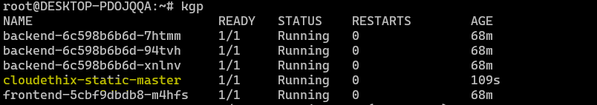

**Que 7 →** Install Kubectx & kubens in your k8s cluster.

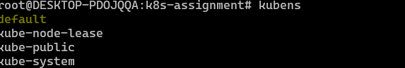

### Que 8 → Create one docker repo flaskwebappvivek

### Git clone the repo <https://github.com/mmumshad/simple-webapp-docker.git>

### Build the image and push into dockerhub.

### 

### 

Created one deployment.yaml and service.yaml



Apply the files and create pods





After this modify the app.py and push the new repo v2 to docker image hub.

Then

root@DESKTOP-PDOJQQA:kube# **k set image deployment my-deployment flask-webapp=vivekmore5292/flaskwebappvivek:v1 --record**

deployment.apps/my-deployment image updated

root@DESKTOP-PDOJQQA:kube# **k edit deployment my-deployment**

deployment.apps/my-deployment edited

root@DESKTOP-PDOJQQA:kube# **k apply -f .**

deployment.apps/my-deployment configured

service/flask-webapp-service unchanged

root@DESKTOP-PDOJQQA:kube# **kubectl rollout status deployment my-deployment**

deployment "my-deployment" successfully rolled out

root@DESKTOP-PDOJQQA:kube# **kubectl rollout history deployment my-deployment**

deployment.apps/my-deployment

REVISION CHANGE-CAUSE

6 kubectl set image deployment my-deployment flask-webapp=vivekmore5292/flaskwebappvivek:v1 --record=true

7 kubectl set image deployment my-deployment flask-webapp=vivekmore5292/flaskwebappvivek:v1 --record=true

**Que 9 →** Download and install Lens & access your k8s cluster from Lens.

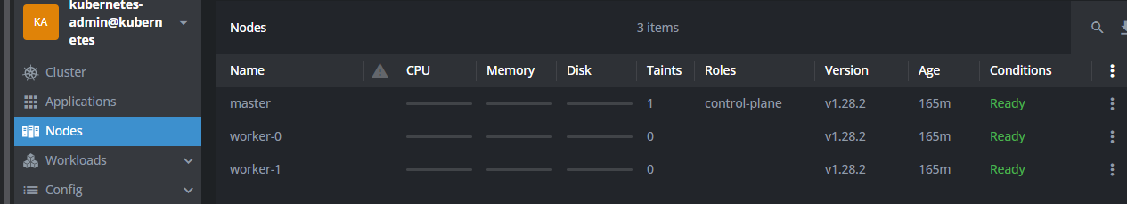

POD

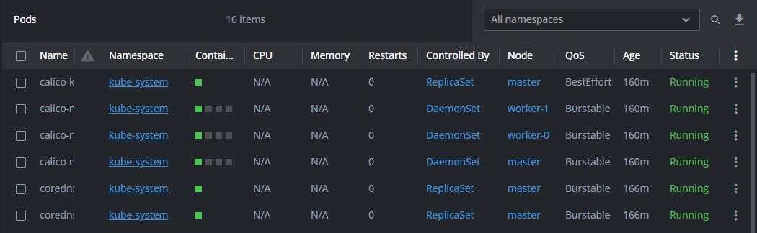

POD logs

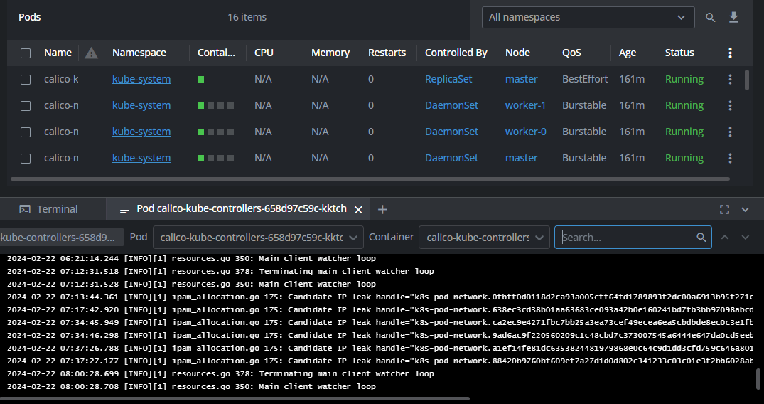

Pod Shell

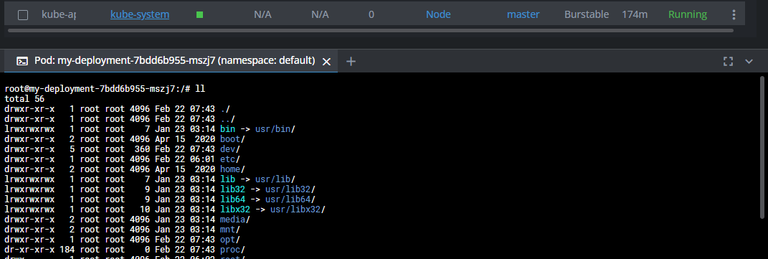

Services

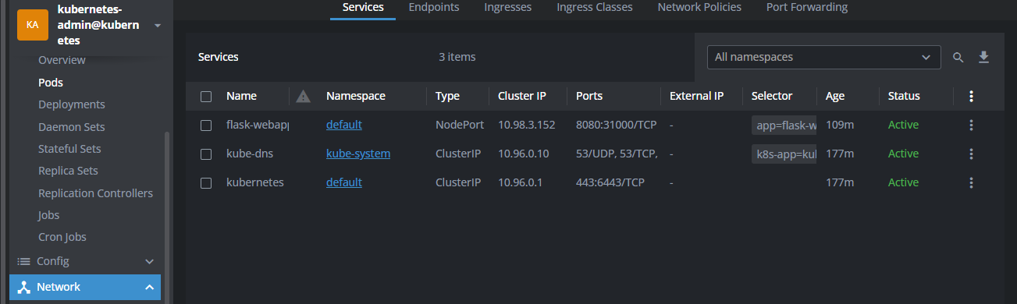

### Que 10 → Create one dockerhub repo vivekmore5292/cloudethix-configmap-vivek

### Create image and push the repo to docker hub.

### 

### Creating two yaml files and write deployement.yaml and service.yaml

### 

### Apply the pods and run on web.

### 

### create a configmap.yaml file with below data & delete the deployment that you have created.

### 

### Then update the same deployment.yaml file and mount configmap as volume on container using

### volumeMounts with mountPath /usr/share/nginx/html/

### 

### Run on web

### 

### Que 11 → Create one repo from docker file and push into new dockerhub repo

### root@DESKTOP-PDOJQQA:Build# docker image build --no-cache -t vivekmore5292/cloudethix-multicontainer-vivek:v1 .

### [+] Building 1144.4s (11/11) FINISHED docker:default

### => [internal] load build definition from Dockerfile 0.1s

### root@DESKTOP-PDOJQQA:Build# docker push vivekmore5292/cloudethix-multicontainer-vivek:v1

### The push refers to repository [docker.io/vivekmore5292/cloudethix-multicontainer-vivek]

### 00cb470b4c56: Pushed

### 72e4fb628d35: Pushed

### dd1eb1fd7e08: Mounted from library/python

### v1: digest: sha256:8bfcc96e07acb8ba1d5d150e7b5bd83c0ddf603e74b08c47efc2b58ae5f0c693 size: 2844

### Now go to deploy folder and apply the yaml files.

### 

### 

### 

### root@DESKTOP-PDOJQQA:Deploy# curl <http://3.129.28.70:30710/init>

### Add user into DB

### 

### access the data that we have added to database using below command.

### root@DESKTOP-PDOJQQA:Deploy# curl http://3.129.28.70:30710/users/1

### John Doeroot

### @DESKTOP-PDOJQQA:Deploy# curl http://3.129.28.70:30710/users/2

### John Doeroot

### @DESKTOP-PDOJQQA:Deploy# curl http://3.129.28.70:30710/users/3

### asfiya shaikhroot

### try to access mysql shell i.e db pod & run select * from the users table. check app.py for DB related information.

### root@DESKTOP-PDOJQQA:Deploy# mysql -u root -p

### Enter password:

### Welcome to the MariaDB monitor. Commands end with ; or \g.

### Your MariaDB connection id is 32

### Server version: 10.6.16-MariaDB-0ubuntu0.22.04.1 Ubuntu 22.04

### MariaDB [(none)]> SHOW DATABASES;

### 

### MariaDB [(none)]> SELECT * FROM mysql;

### ERROR 1046 (3D000): No database selected

### MariaDB [(none)]> USE mysql;

### Reading table information for completion of table and column names

### You can turn off this feature to get a quicker startup with –A

### 

### Que 12 → Create one Dockerhub Repo vivekmore5292/cloudethix-initcontainer-vivek

### Push the image into dockerhub.

### root@DESKTOP-PDOJQQA:simpleapp# docker image build --no-cache -t vivekmore5292/cloudethix-initcontainer-vivek:v1 .

### root@DESKTOP-PDOJQQA:simpleapp# docker push vivekmore5292/cloudethix-initcontainer-vivek:v1

### after that create two Yaml file.

### 

### Kgp

### 

### After that check on web browser.

### 

### Update the deployment.yaml file and add volumeMounts with mountPath /usr/share/nginx/html from emptyDir: {} volume

### Add the code into deployment and re-apply the pod.

### Check on web.

### Que 13 → Create one repo on dockerhub vivekmore5292/cloudethix-hpa-vivek

### Push the image into docker hub.

### root@DESKTOP-PDOJQQA:kubernetes-hpa-example# docker image build --no-cache -t vivekmore5292/cloudethix-hpa-vivek:v1 .

### root@DESKTOP-PDOJQQA:kubernetes-hpa-example# docker push vivekmore5292/cloudethix-hpa-vivek:v1

### 

Run the Deployment file and service files.

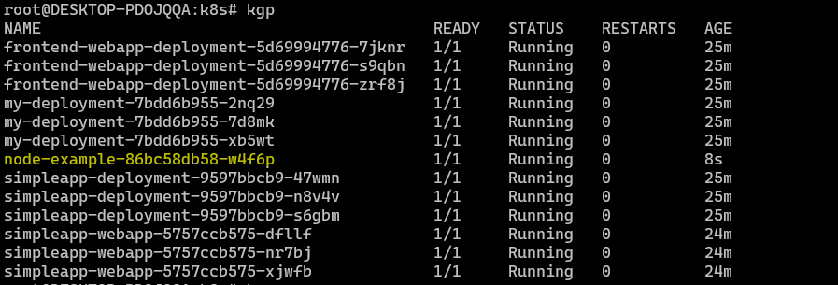

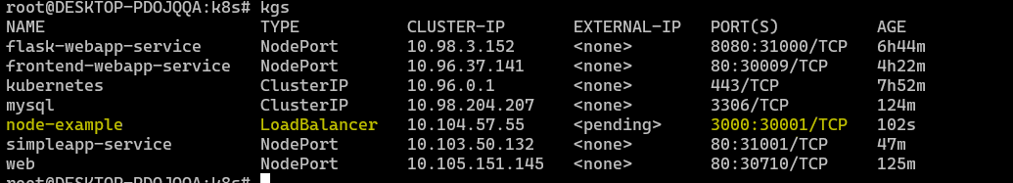



Run the below command

root@DESKTOP-PDOJQQA:k8s**# kubectl run -i --tty load-generator --rm --image=busybox --restart=Never -- /bin/sh -c "while sleep 0.01; do wget -q -O- http://node-example; done"**

root@DESKTOP-PDOJQQA:k8s# **kubectl get hpa**



### Que 14 → Create one docker hub repo vivekmore5292/cloudethix_cronjob_vivek

### Crate image and push on docker hub with appropriate tag.

### Create 3 files and apply it

### 

### After that check the cronjob.

### root@DESKTOP-PDOJQQA:cronjob# kubectl get cronjobs

### NAME SCHEDULE SUSPEND ACTIVE LAST SCHEDULE AGE

### python-helloworld */1 * * * * False 0 42s 45s

### 

root@DESKTOP-PDOJQQA:cronjob# k logs python-helloworld-28477841-dhv7t

Welcome to the Cloudethix World

Today is

2024-02-23 06:41:01.003264

